4th Annual Adult Field Day Presented by Nspire Me 365

Tirongila H-Jason
Nspire Me 365
Slidell, La. 70458

Dear Potential Sponsor:

Please join us as we prepare for one of our biggest FUNdraiser events(heavy of the fun) of the year

Our 4th Annual Adult Field Day will take place on June 4, 2023(projected date) at Fritchie Park Slidell. This event will help to raise money for Nspire Me 365, Slidell- a local non-profit organization and mentoring program for young girls and women. Our goal is to raise 5,000 and we’re hoping that you can help us reach that goal.

By becoming one of our sponsors, you’ll be helping to make a difference in our community and the lives of others. All proceeds will benefit the Nspire Me 365 Foundation.

We empower by giving back and giving a hand up. With the help of your donation or sponsorship you will be helping to:
- Assist young girls and women in our community
- Empower women through Learning Seminars & Empowerment Sessions( Applied Knowledge is power)
- Offset event expenses-This helps us to raise more money instead of putting out more money
- Provide book scholarships for college students
- Help to aid in graduation cost for high school seniors(class ring, senior trip, prom dress, senior dues)
- Help purchase uniforms and supplies for underprivileged kids
- Fund business registration(LLC) for upcoming entrepreneurs
- Adopt a home in low income areas(providing cleaning supplies & basic furnishings: blinds, comforter sets, furniture, etc)
- Make a difference in our community and help us reach more girls/women
- Aid with utility bills(electric)
- Provide gas cards
- Strengthen community ties

Perks for giving! We didn’t leave you out. In appreciation of your anticipated donation/sponsorship. You will receive credit for your contribution(s).
- Get credit at the end of the year for your giving, we are acknowledged by the IRS as a 501(c)(3) public charity. We’ll provide all donors/sponsors with a letter from the IRS confirm our tax exempt status.(under IRC Section 170)
- Business promotion/advertisement
- Event yearbook(see sponsorship packages)
- Certificate /Plaque of Recognition
- Connect with your community and much more

See the attached sponsorship levels to find the level that’s right for your company. To learn more about our mission, vision and what we do please visit www.nspireme365.org

I’d like to thank you in advance for your generosity. Remember, your donation makes a difference. Please don’t hesitate to contact me directly at 985-265-5425 or email nspireme365.@gmail.com

Sincerely,
Tirongila Jason-Founder & Organizer
Federal Tax Id: 82-4800039

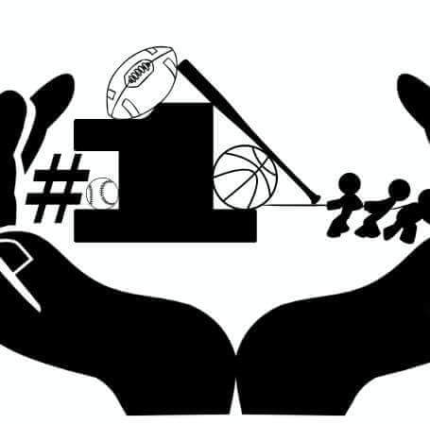 | 4th ANNUAL ADULT FIELD DAY

Sponsor Application

Applicant Information
Sponsor Name: |  |  |  | Date:
 | Last | First | M.I.

Business Name: ________________________________________________________________________ Social Media: _______________
Mailing Address:
 | Street Address | Apartment/Unit #

 | City | State | ZIP Code

Phone: |  | Email

Donation & Sponsorship package: please circle one.
See Sponsorship levels & make a contribution you’re comfortable with. Find the giving level that’s right for you(r) company
- Donation of any amount (See details below)
- Cooling Station Sponsor (fund water misted fans for event & Gatorade/Powerade for teams)
- Business Sponsor (See details below)
- Lead Sponsor (See details below)

3 ways to give: online @www.nspireme365.org | Clippers Barbershop 622 Robert Blvd. Slidell | Tee’s Catering 280 Howze Beach Rd. Slidell
PLEASE REVIEW AND SELECT THE PACKAGE THAT BEST SUITES YOU.
Any amount $300 $500 $5000
- Certificate of appreciation
- Name on donors list

DONATION
COOLING STATION

- Business/sponsor name on sponsorship pg of yearbook & website
- Certificate of appreciation
- ¼ pg in event yearbook

LEAD SPONSOR
- Rights to all promotion banners, signage, event tickets, shirts, flyers
- Social media business promotion & website banner
- Business plaque
- Free Event shirt & all memorabilia
- Free Event yearbook
- ½ pg. yearbook advertisement
- Business Plaque

BUSINESS SPONSOR

- Certificate of appreciation
- ½ pg business advertisement in event yearbook
- Business advertisement in event video
- Social Media business promotion
- Event Memorabilia

Office Use Only:

Amount Enclosed ________ Check # ________ Time Rcd ________ Initial ________

